Suggestion for a newsletter article
Help Get Our Local History out to a National and International Audience

The Historical Marker Database, HMdb.org, and its 7000 volunteer marker hunters have a goal: to find and document every historical marker in North America. They’re been at it since 2006, and in the past few years they’ve been adding hundreds of markers each week. With more than 200,000 markers in their database so far, it is a treasure-trove of local history.
But they are nowhere near done, says HMdb publisher J.J. Prats, also a volunteer. They have a big problem: there is no comprehensive list of historical markers to work from. “We’ll never know when we’re done!,” he says with a laugh.
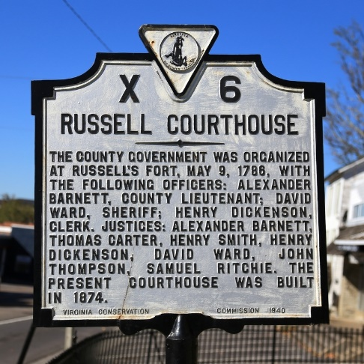
When one of their volunteer marker-hunters —their official title is Contributing Correspondent — travels to an area, typically with a hand-written want list in their pocket, they often stumble across other qualifying historical markers not on their list. But they’re not from there, so they won’t know that if they don’t turn at that particular corner they are going to miss a piece of local history.
A Photo of one of your markers here
Historical societies like us keep track of historical markers we’ve had a hand in erecting. In our case, we were instrumental in getting _____ markers erected over the years, including the most recent, ______________________________________ located at ____________________________. But what about the historical plaques and signs others have put up? [Even we don’t necessarily know what we have, marker-wise, in the area we are responsible for.]
Some of our historical markers are in the Historical Marker Database. If we want the world to know about the history we find so fascinating, perhaps we should plant more summaries of our history on a national website like HMdb.org by making sure they list every single one of our historical markers.
HMdb provides an individual website page for each historical marker, with space for multiple photographs and additional commentary. Anyone can become a contributing correspondent. Just upload photos of markers, type out their text, and enter location information into their online forms and you automatically become a correspondent.
One of their volunteer editors will make sure all the required information is there, corresponding with you by email if necessary, and will publish your pages. Their comprehensive search and mapping functions will pick up the new entries immediately, and search engines like Google and Bing will index them minutes after they are published. And with that you’re a Contributing Correspondent! They’ll even send you wallet cards to carry around and hand out.
So what do you think? Are any of our members interested in making sure our history is represented in The Historical Marker Database? Take a look as their Submission Guidelines and Suggestions page and put our local history on the national map!

